# PIZZA SALES: SQL, EXCEL AND POWER BI

**1. Description**

The Pizza Sales Analytics project focuses on understanding sales performance by analyzing key metrics such as total revenue, average order value, total pizzas sold, and sales trends. The project uses SQL, Excel, and Power BI for data extraction, transformation, visualization, and dashboard creation. The goal is to identify sales patterns, top-selling and worst-selling pizzas, and insights into customer preferences.

**2. Plan**

The project follows a structured approach to data analysis:

* **Define Objectives**: Understand pizza sales performance and optimize business strategies.
* **Identify KPIs**: Track revenue, order volume, and sales distribution by pizza category and size.
* **Select Data Sources**: Sales transaction data from an SQL database.
* **Determine Analytical Techniques**: Use SQL queries for data extraction and trend analysis, and Power BI for visualization.
* **Create Dashboard**: Build an interactive sales dashboard to visualize insights.

**3. Prepare**

* **Data Collection**: Import sales data into SQL Server Management Studio (SSMS).
* **Data Cleaning**: Handle duplicate order IDs, ensure consistency in pizza categories, and resolve missing values.
* **Data Transformation**: Apply SQL queries for data aggregation and percentage calculations.
* **Data Enrichment**: Calculate key metrics such as revenue, order value, and sales proportions.

**4. Process**

* **SQL Queries for Sales Trends**:
  + Daily sales analysis (by day name).
  + Monthly trend analysis (by month name).
* **Category & Size Sales Analysis**:
  + Percentage of sales by pizza category and size.
* **Performance Ranking**:
  + Identify top 5 best-selling and worst-selling pizzas based on revenue, quantity sold, and total orders.
* **Data Visualization**:
  + Build charts in Power BI to showcase trends, best and worst sellers, and category-wise performance.

**5. Analyze**

The dashboard analysis covers:

* **Daily Sales Trends**: Sales patterns based on days of the week.
* **Monthly Trends**: Seasonal variations in pizza orders.
* **Sales by Category & Size**: Determines which pizza types and sizes contribute most to revenue.
* **Best-Selling Pizzas**: Top 5 pizzas based on revenue, quantity sold, and order volume.
* **Worst-Selling Pizzas**: Bottom 5 pizzas in sales, helping identify areas for improvement.

**6. Insights & Key Findings**

**1. Sales Trends**

* Sales peak on weekends, indicating high demand during leisure periods.
* Monthly trends show an increase in sales during holiday seasons.

**2. Pizza Category & Size Preferences**

* Certain pizza categories dominate sales, showing strong customer preferences.
* Medium-sized pizzas have the highest sales volume, likely due to affordability and shareability.

**3. Best-Selling Pizzas**

* The top 5 pizzas consistently generate the highest revenue and order volume.
* Popular flavors and promotions significantly impact sales.

**4. Worst-Selling Pizzas**

* Some pizzas show consistently low sales, possibly due to pricing, taste preferences, or lack of promotions.
* Reviewing these items can help optimize menu offerings.

**5. Average Order Value & Quantity per Order**

* Customers typically order around 2 pizzas per order.
* Promotional offers and combo deals could increase average order value.

**7. Share**

* **Dashboard Creation**:
  + Interactive Power BI charts for sales trends, category distribution, and performance ranking.
  + Filters to explore daily, monthly, and category-wise sales.
* **Report Distribution**:
  + Exporting reports to PDF or embedding them in business review meetings.
  + Sharing dashboard links with management for real-time sales tracking.

**8. Act**

Based on the analysis, key business actions include:

* **Weekend Promotions**: Offer discounts on peak sales days to maximize revenue.
* **Menu Optimization**: Remove or improve worst-selling pizzas.
* **Bundle Deals**: Introduce combo offers to increase order value.
* **Size-Based Pricing**: Adjust pricing strategies based on the most popular pizza sizes.
* **Seasonal Marketing**: Target high-sales months with special promotions.

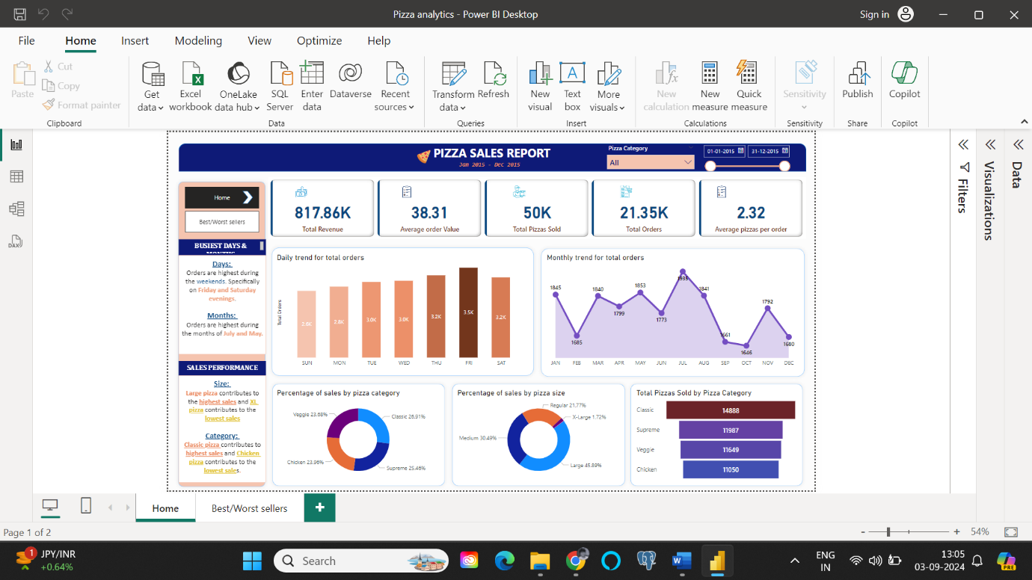

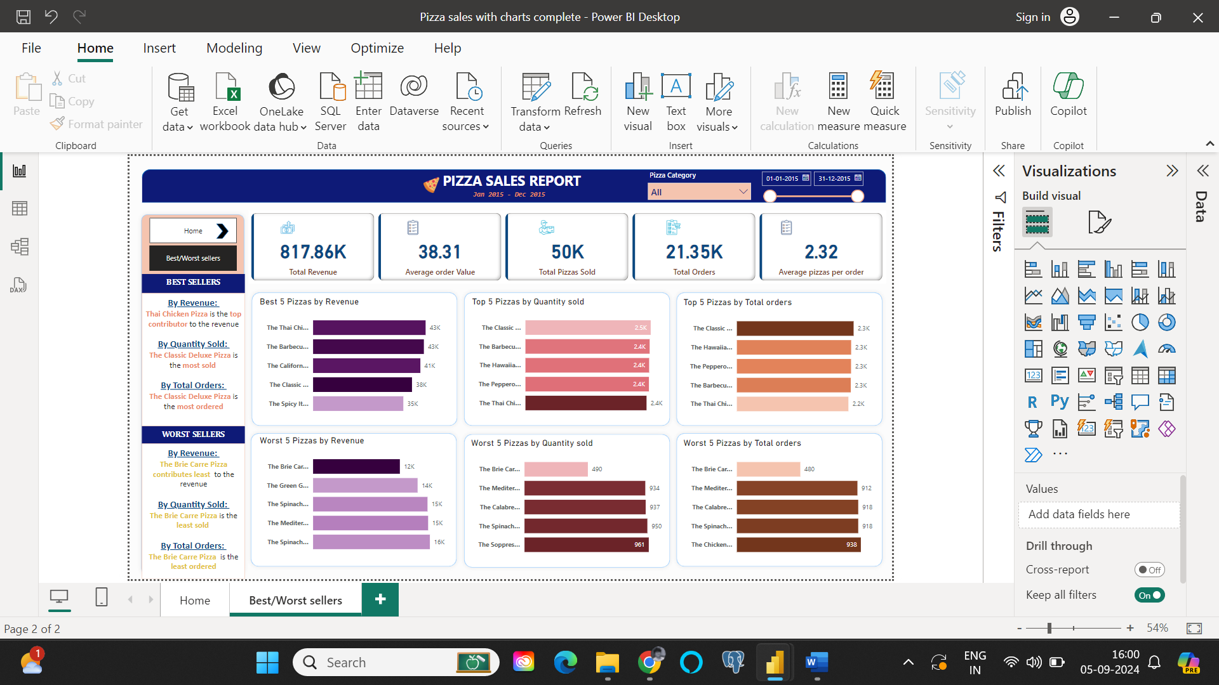

# PIZZA SALES ANALYSIS DASHBOARD

MS SQL SSMS SERVER NAME: DESKTOP-D1Q2FF9\SQLEXPRESS

KPIs

1. Total Revenue:

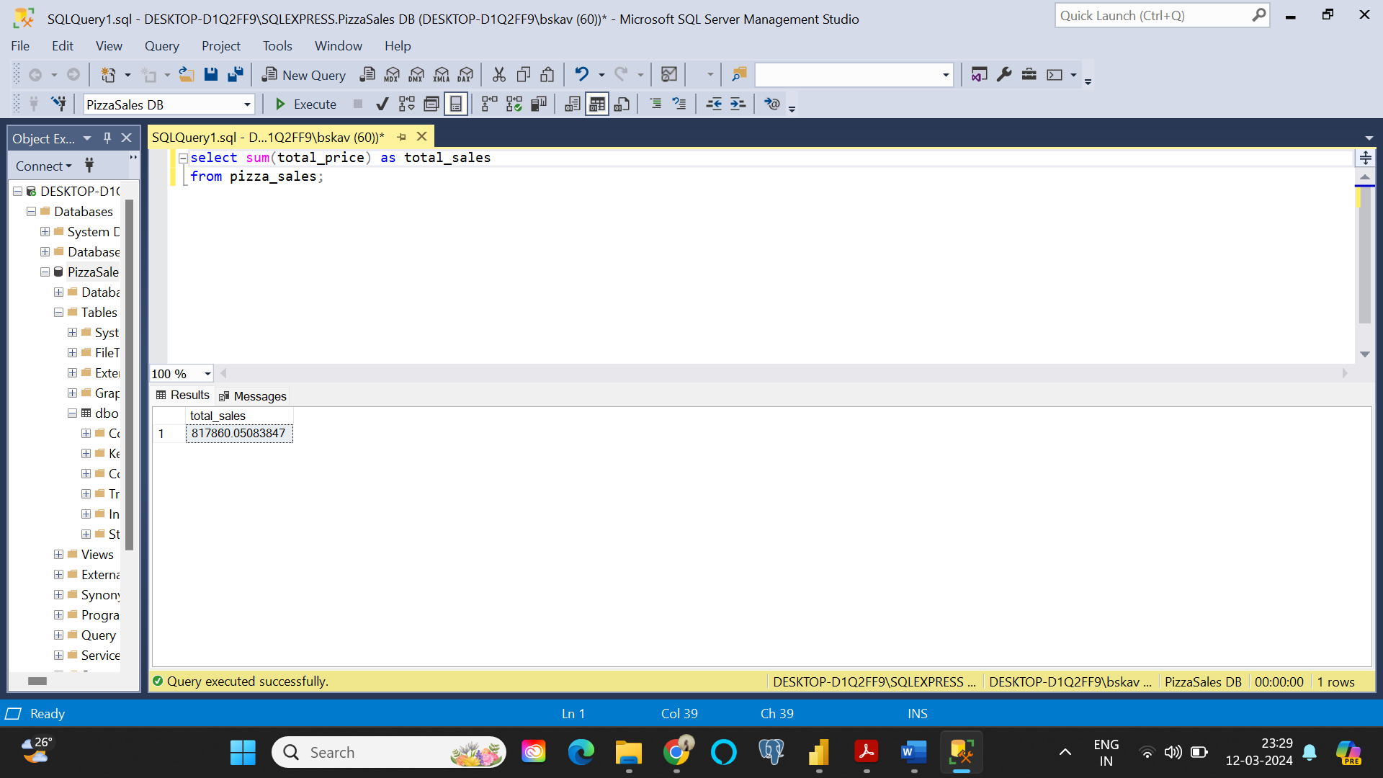

1. Average Order Value:

Since order_id has duplicates, cannot use count on it directly, instead, need to use count of DISTINCT order_id

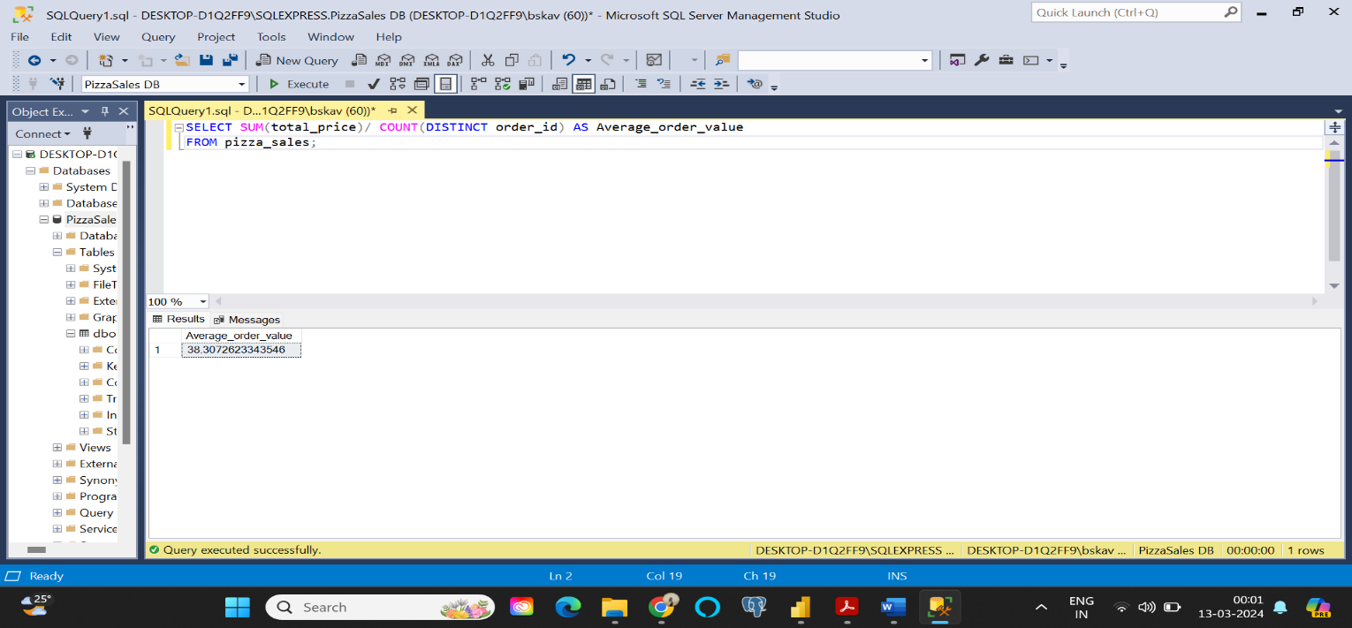

1. Total Pizzas sold:

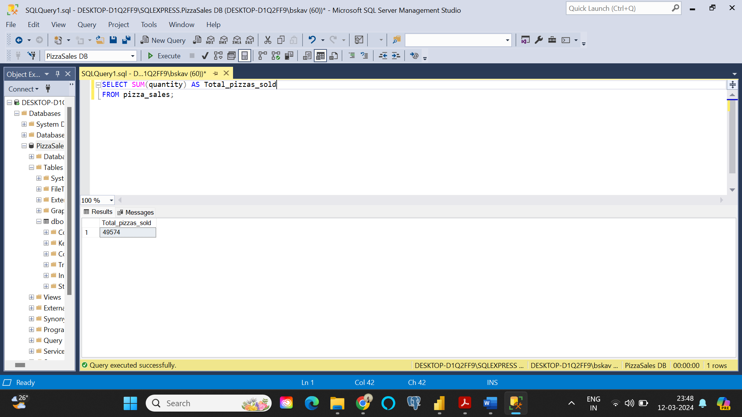

1. Total Orders:

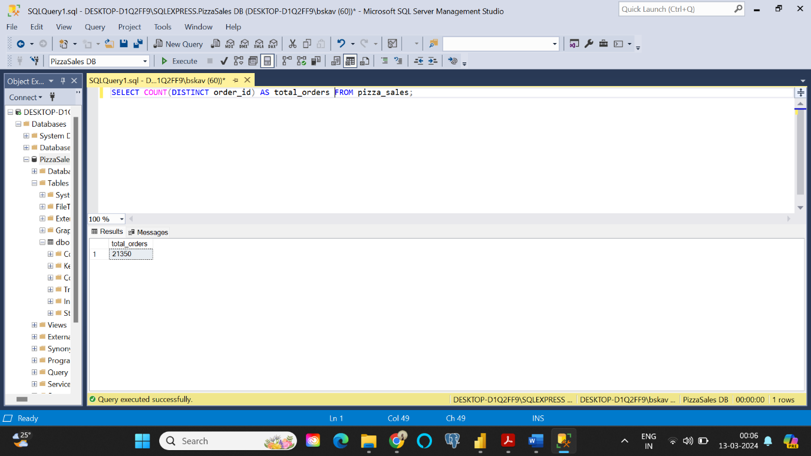

1. Average Pizza Per Order:

When queried, although the answer 2 is right, it is rounded off. Hence, both numerator and denominator need to be casted to a decimal value. The whole result again can be casted off as well. But here it is not required.

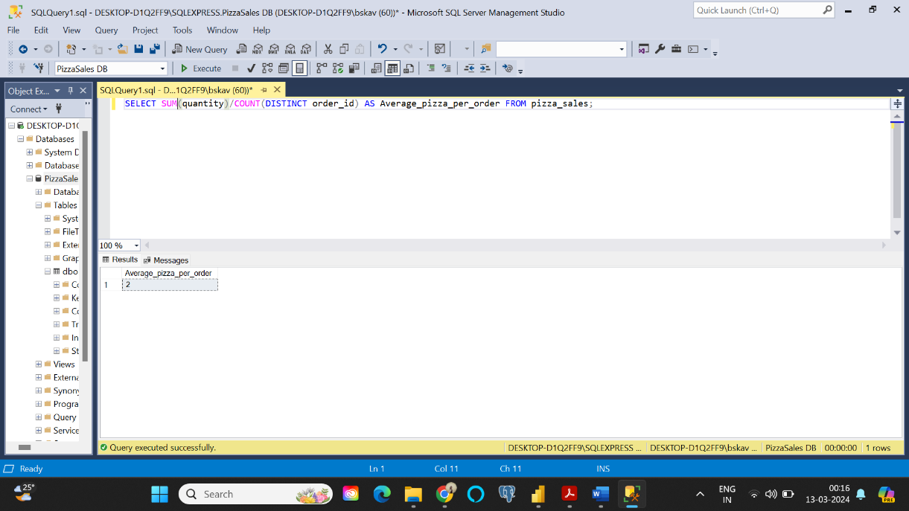

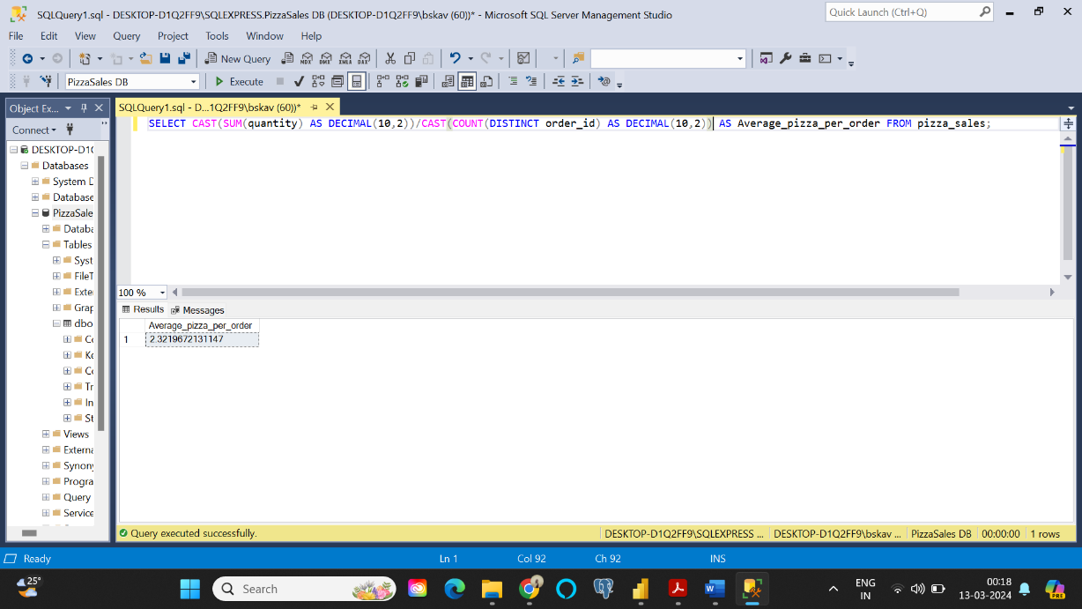

CHARTS:

1. **Daily sales (by day names):**

Can also use ‘weekday’ instead of DW.

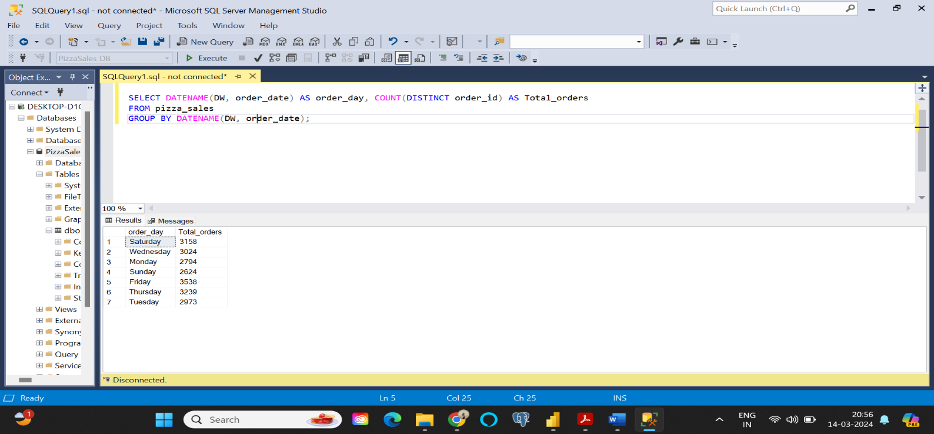

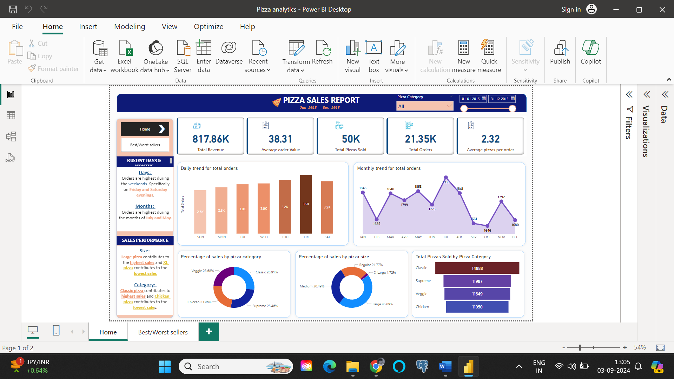

1. **Monthly Trend for total orders (by month names):**

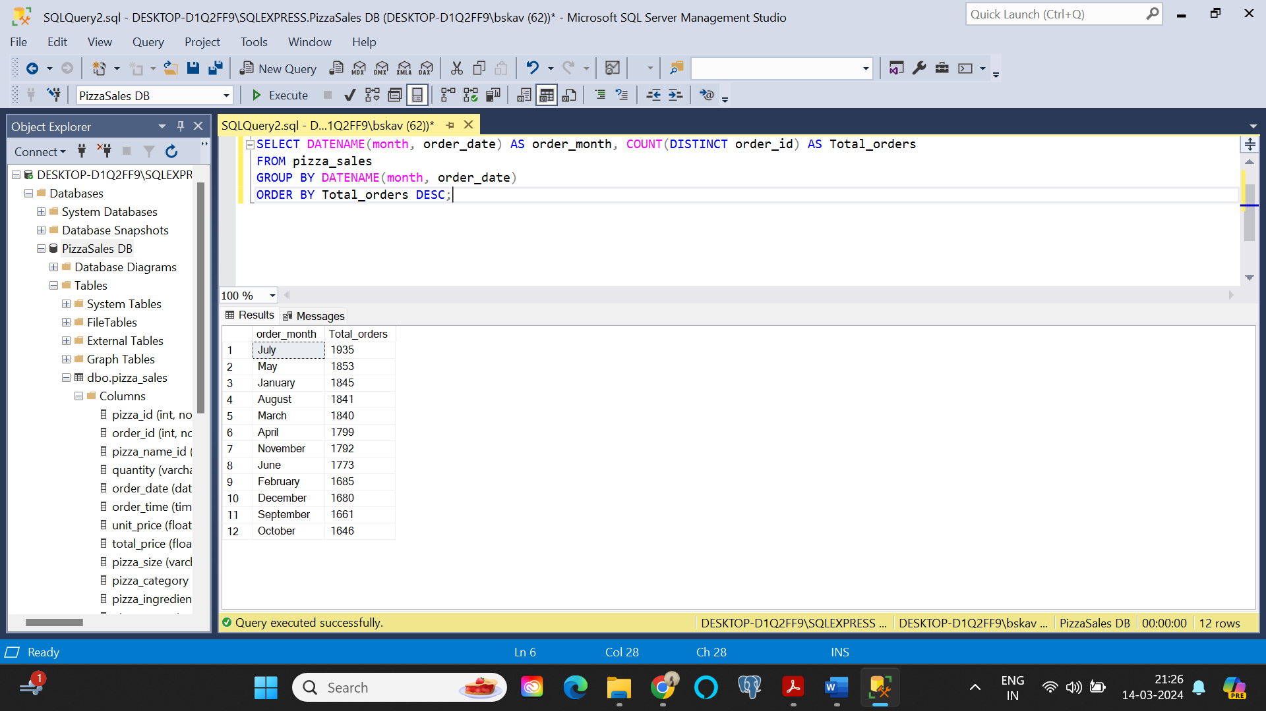



1. **Percentage of sales by pizza category:**

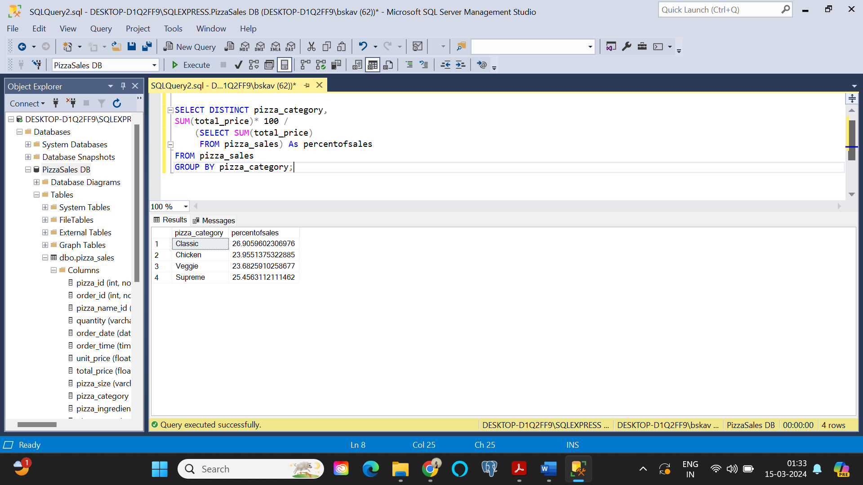

1. **Percentage of sales by pizza size:**

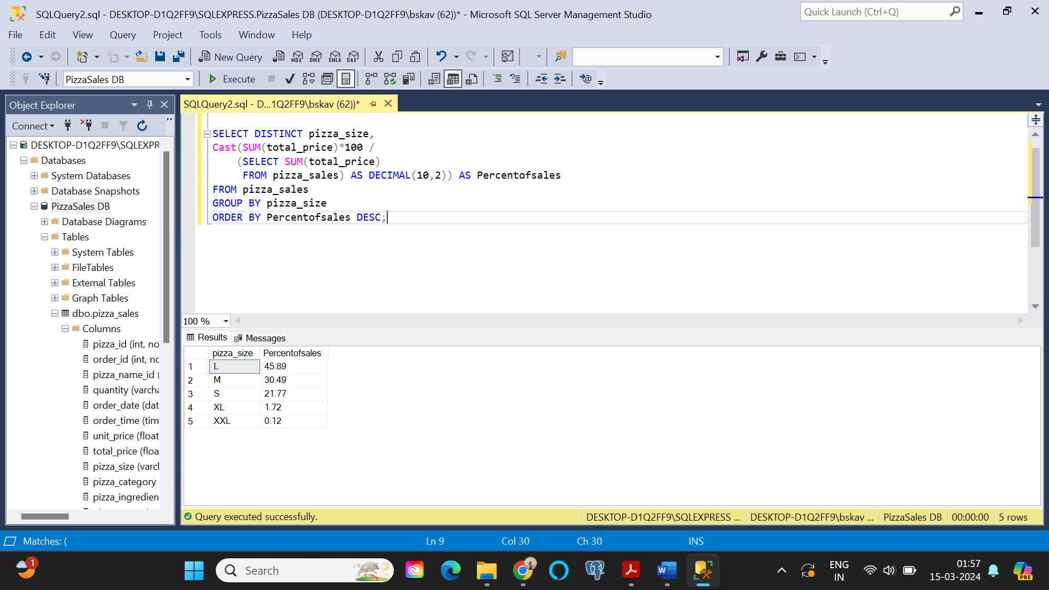



1. **Total Pizzas sold by pizza category:**

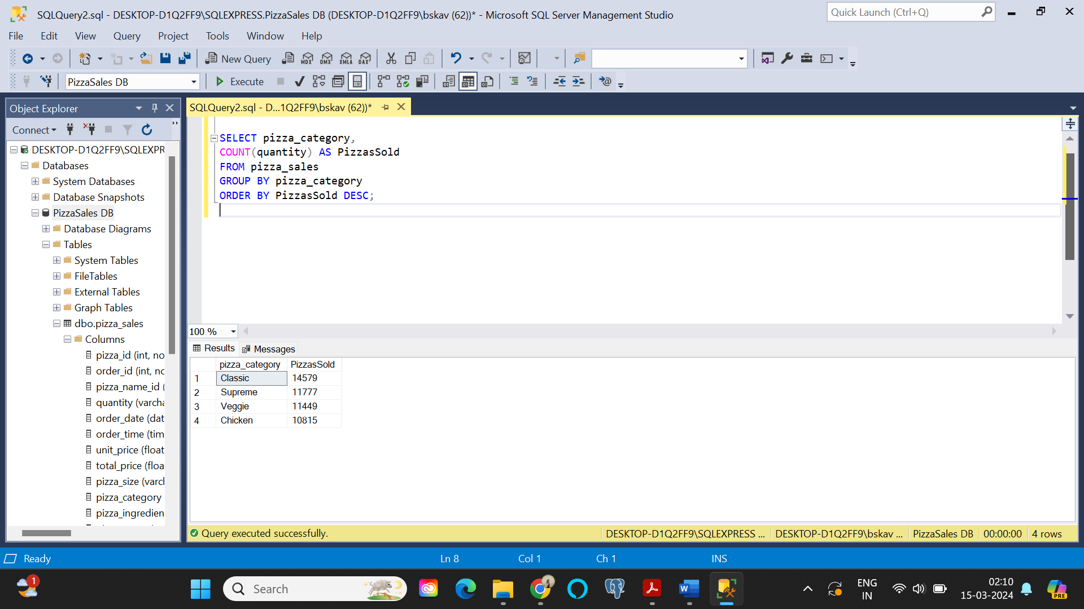



1. **Top 5 best sellers by : Revenue, Total quantity sold, Total orders**
2. **Top 5 by revenue:**

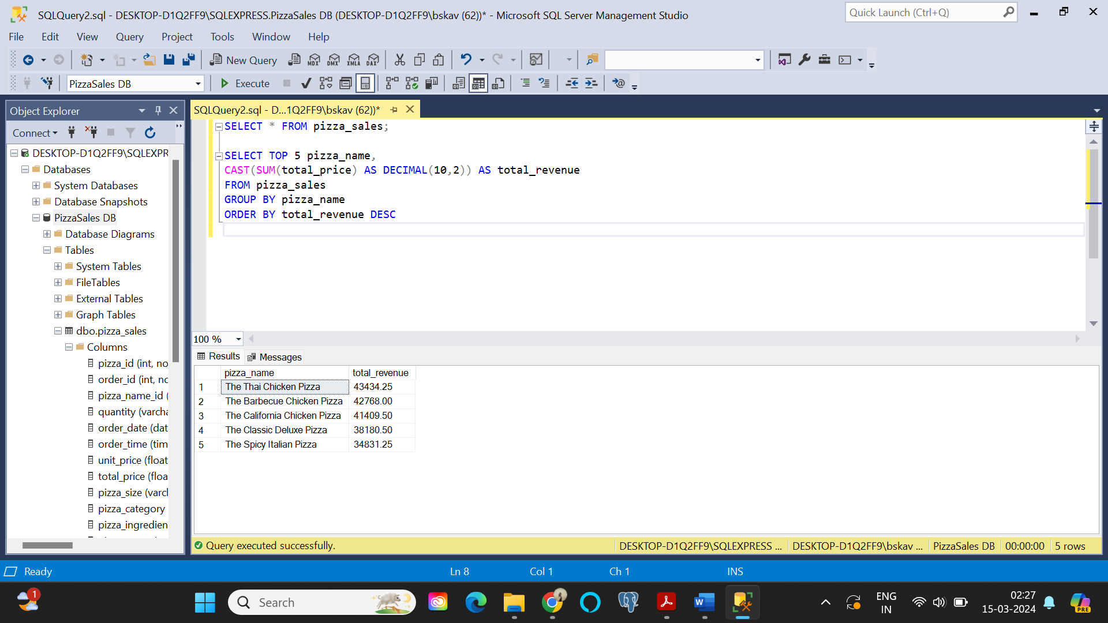



1. Top 5 by Total quantity sold:

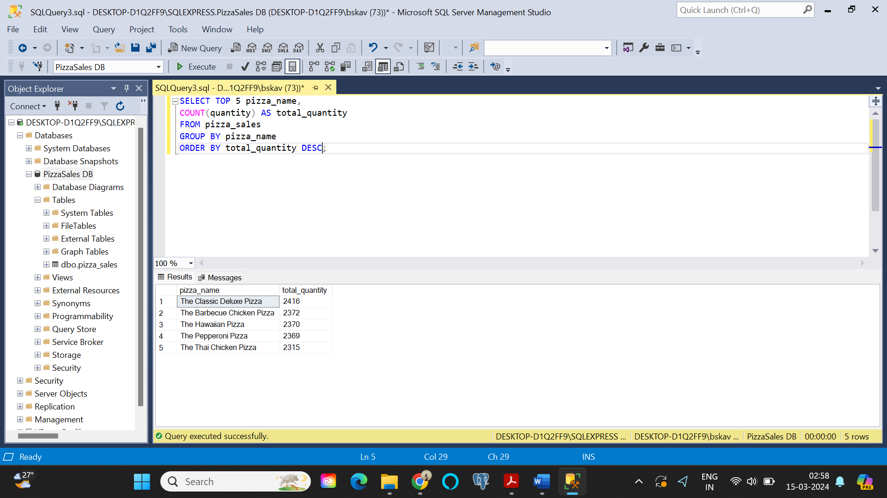



1. Top 5 by Total Orders:

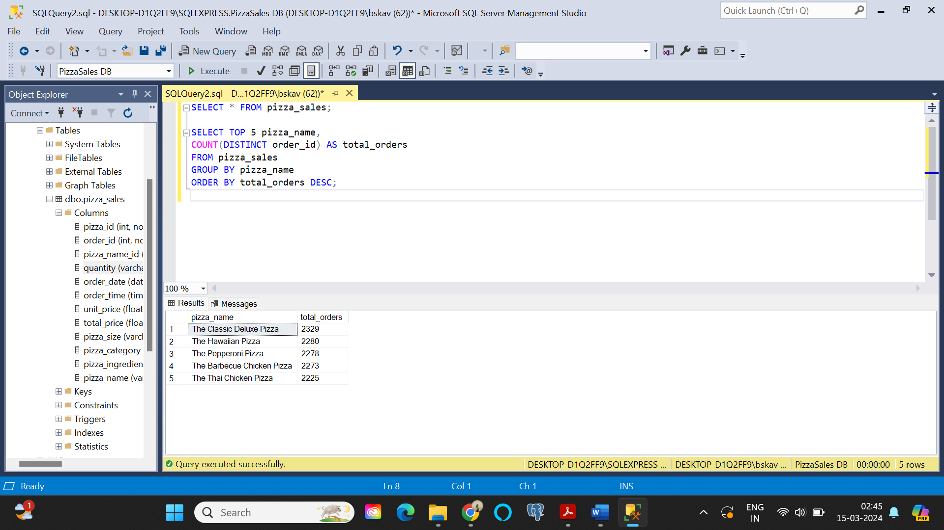



1. Top 5 worst sellers by: Revenue, Total quantity sold, Total orders
2. Worst 5 by revenue:

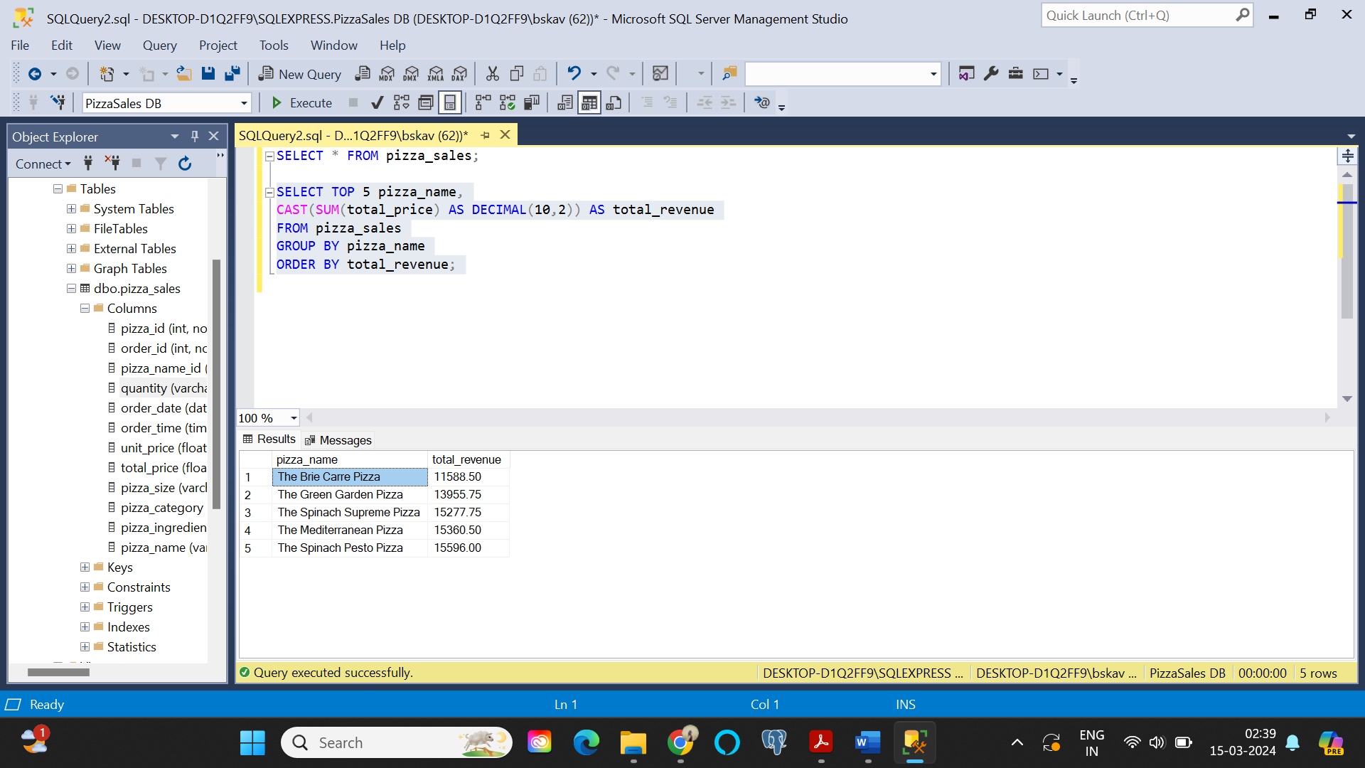



1. Worst 5 by Total quantity sold:

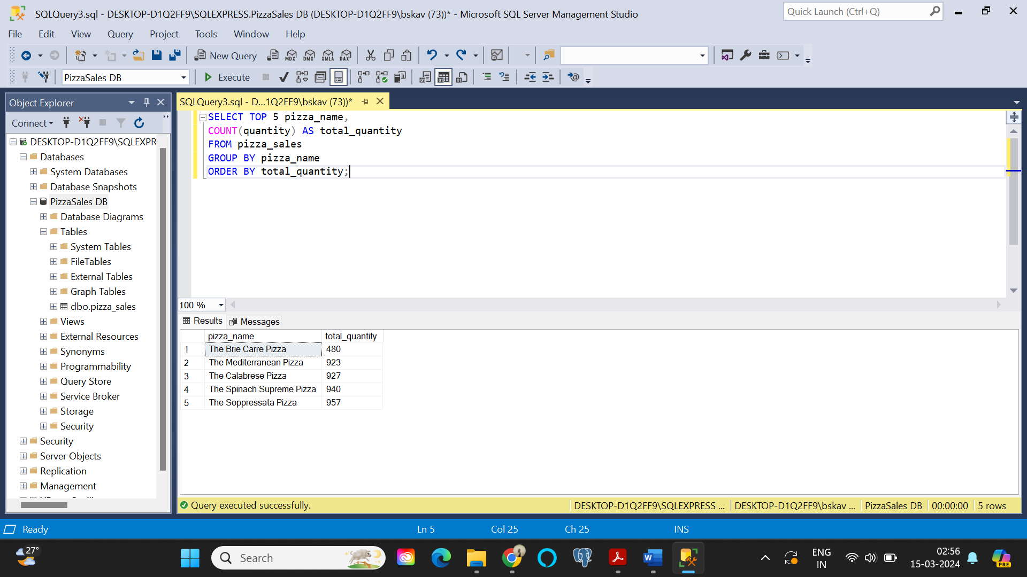



1. Worst 5 by Total orders:

